1. The department name could possess numbers as well as letters. Thus, the need for varchar.
   1. The length is set to 25 to incorporate larger company names
   2. Dnumber is an integer and the primary key so it needs to be unique to all stores.
2. We need two primary keys in dnumber and dlocation because we will use dnumber as Foreign Key later in the process.
3. 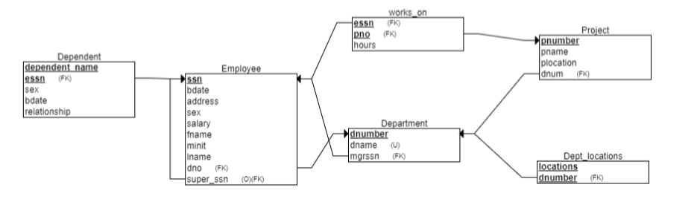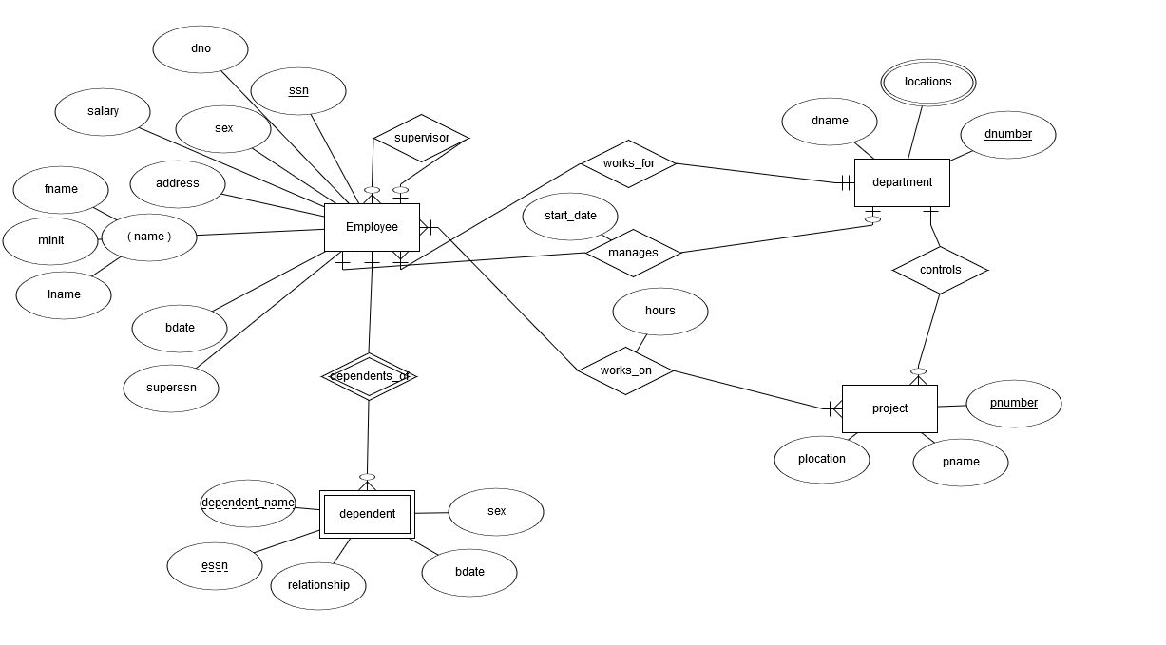True. In a foreign key reference, a link is created between two tables when the column or columns that hold the primary key value for one table are referenced by the column or columns in another table.

5.

